Project Development Phase Sprint IV
Date | 15 November 2022
Team ID | PNT2022TMID 44492
Project Name | Project - Signs with smart connectivity for Better road safety

Code for print the random temperature, Road signs, Speed limit, Message :
( RandomValues.py )

import wiotp.sdk.device import time
import random
import ibmiotf.application import ibmiotf.device import requests, json
myConfig = {
#Configuration "identity": {
"orgId": "n6rl9n", "typeId": "NodeMCU", "deviceId":"621319106312"
},
#API Key "auth": {
"token": "9876543210" }
}
#Receiving callbacks from IBM IOT platform def myCommandCallback(cmd):
print("Message received from IBM IoT Platform: %s" % cmd.data['command']) m=cmd.data['command']
client = wiotp.sdk.device.DeviceClient(config=myConfig, logHandlers=None) client.connect()
#OpenWeatherMap Credentials
BASE_URL = "https://api.openweathermap.org/data/2.5/weather?" CITY = "Salem, IN"
URL = BASE_URL + "q=" + CITY + "&units=metric"+"&appid=" + "f58e4720c739a54c439aba9b05176839"
while True:
response = requests.get(URL) if response.status_code == 200:
data = response.json() main = data['main'] temperature = main['temp'] humidity = main['humidity'] pressure = main['pressure'] report = data['visibility']
#messge part msg=random.randint(0,5) if msg==1:
message="GO SLOW, SCHOOL ZONE AHEAD" elif msg==2:
message="NEED HELP, POLICE STATION AHEAD" elif msg==3:
message="EMERGENCY, HOSPITAL NEARBY" elif msg==4:
message="DINE IN, RESTAURENT AVAILABLE" elif msg==5:
message="PETROL BUNK NEARBY" else:
message=""
#Speed Limit part speed=random.randint(0,150) if speed>=100:
speedMsg=" Limit Exceeded" elif speed>=60 and speed<100:
speedMsg="Moderate" else:
speedMsg="Slow"
#Diversion part sign=random.randint(0,5) if sign==1:
signMsg="Right Diversion" elif sign==2:
signMsg="Speed Breaker" elif sign==3:
signMsg="Left Diversion" elif sign==4:
signmsg="U Turn" else:
signMsg=""
#Visibility
if temperature < 24:
visibility="Fog Ahead, Drive Slow" elif temperature < 20:
visibility="Bad Weather" else:
visibility="Clear Weather" else:
print("Error in the HTTP request")
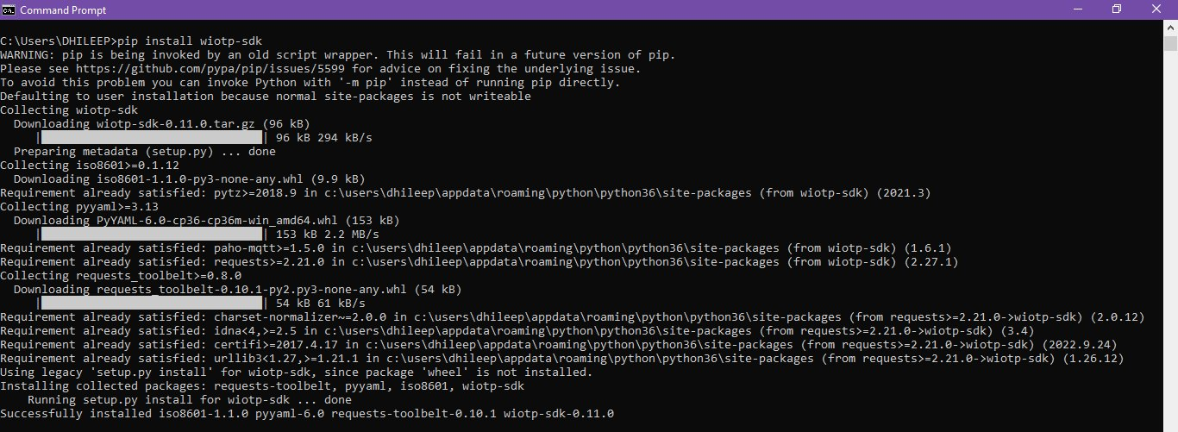
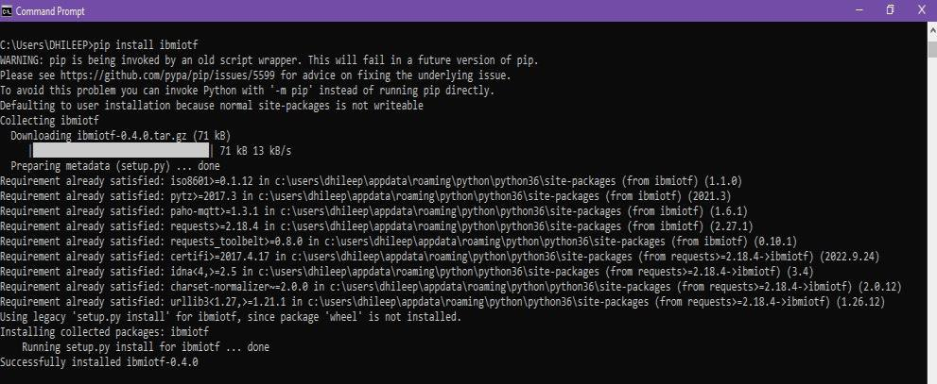
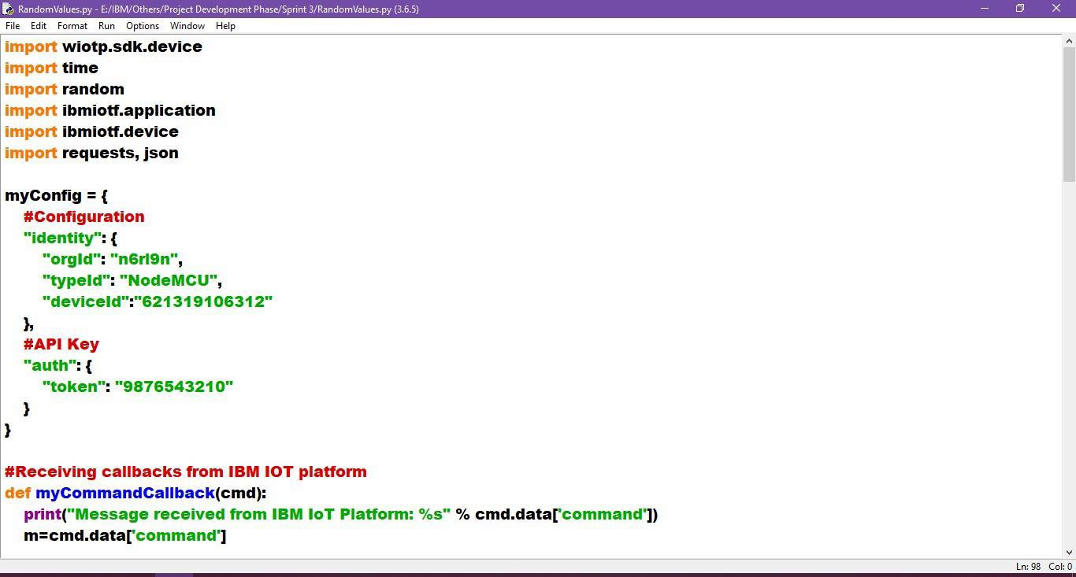
myData={'Temperature':temperature, 'Message':message, 'Sign':signMsg, 'Speed':speedMsg, 'Visibility':visibility}
client.publishEvent(eventId="status", msgFormat="json", data=myData, qos=0, onPublish=None) #PUBLISHING TO IOT WATSON
print("Published data Successfully: ", myData) print("
") client.commandCallback = myCommandCallback time.sleep(5)
client.disconnect()

Python Simulation :

Import wiotp-sdk & ibmiotf :
OpenWeatherMap - (Ex., Salem, IN) :

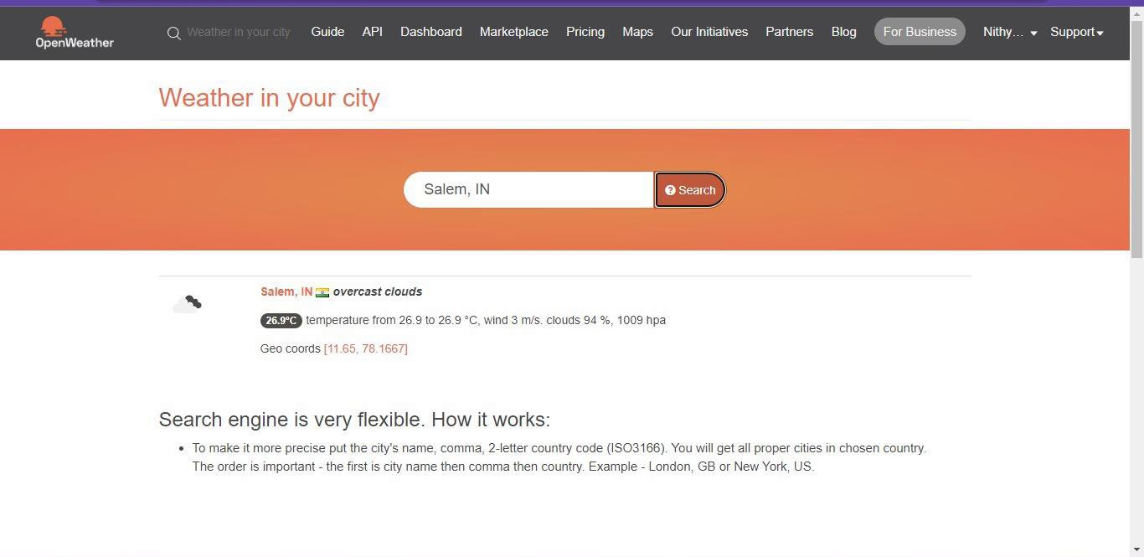
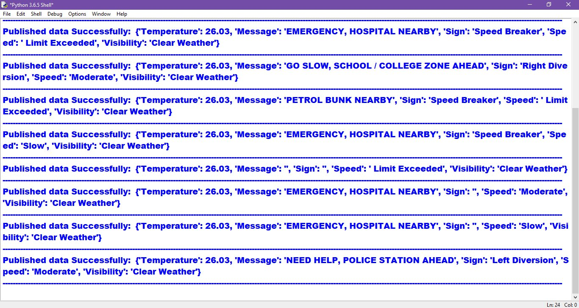
Python IDLE Output :

